NATIONAL CHEMISTRY OLYMPIAD 2025

ASSIGNMENTS PRELIMINARY ROUND 2
To be held between 17th and 25th March 2025

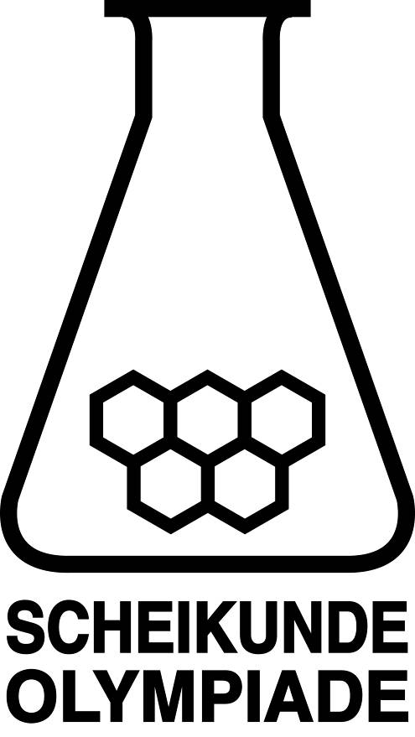



- This preliminary round consists of 20 multiple choices questions divided over 8 topics, and 3 problems with a total of 16 open questions, in addition to an answer sheet for the multiple choice questions.
- Use the answer sheet to answer the multiple choice questions.
- For the open questions, use a separate answer sheet for each of the three problems. Remember to include your name on each sheet.
- The maximum score for this paper is 98 points.
- The preliminary round lasts three hours in total.
- Required materials: (graphic) calculator and BINAS 6th or 7th edition or ScienceData 1st edition or BINAS 5th edition, English version. “Green chemistry” table is included.
- The total number of points available for each question is stated.
- Unless otherwise stated, standard conditions apply: T = 298 K and p = p₀ .

This test was made possible with the support of the following people:
Olav Altenburg
Alex Blokhuis
Johan Broens
Jacob van Hengst
Dick Hennink
Emile de Kleijn
Jasper Landman
Bob Lefeber
Marte van der Linden
Piet Mellema
Han Mertens
Anna Reinhold
Joran de Ridder
Geert Schulpen
Eveline Wijbenga
Emmy Zeetsen

The final editing was done by:
Kees Beers, Martin Groeneveld and Pia Scheffer

The test was translated into English by:
Lilian Buuron
Riëtte Pienaar
Jan Rombach
Lauren Rutherford
Alex Schaeffers

- Multiple choice questions total 40 points
For each question, write your answer (letter) on the answer sheet. The answer sheet can be found at the end of this examination booklet.
Marks: 2 points for each correct answer.
 |  | Carbon chemistry
The next two questions are about the ozonolysis of alkenes.
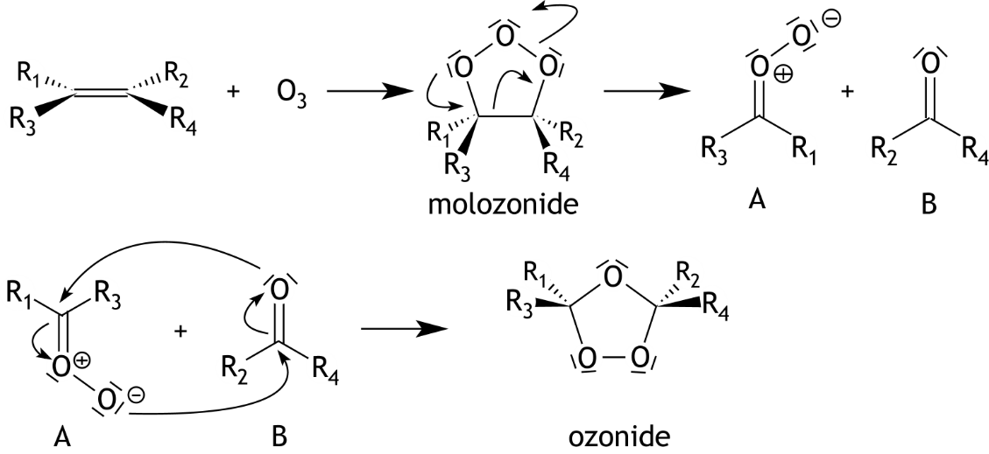
Alkenes can react with ozone, O₃, forming a so-called ozonide. The reaction proceeds via a so-called molozonide and two intermediates A and B as follows:

In this reaction stereoisomers can be formed.
1 |  | How many molozonides can be formed in the following two cases?  I R₁ to R₄ are different.  II R₁ = R₂ and R₃ = R₄  Assume that the ozone molecule reacts with the alkene molecule in one step.
 |  | I II
 | A | 1 1
 | B | 1 2
 | C | 2 1
 | D | 2 2
 | E | 4 1
 | F | 4 2
2 |  | 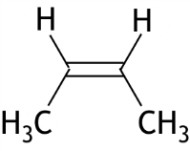  How many ozonides can be formed in the ozonolysis of the alkene below?  Consider stereoisomerism.
 | A | 1
 | B | 2
 | C | 3
 | D | 4

3 |  | There is a large number of possible structures with the molecular formula C₆ H₁₀.  How many of these structures contain both a cyclobutane ring and a double bond? Consider stereoisomerism.
 | A | 2
 | B | 3
 | C | 4
 | D | 5
 | E | 6
 | F | 7
 | G | 8
 | H | 9
 | I | 10
 |  |  | Reaction rate and equilibrium
4 |  |  | 5.00 g of nitrogen dioxide is introduced in a closed reaction vessel with a fixed volume of 1.00 dm³. The following equilibrium is reached:  N₂O₄(g) 2 NO₂(g)  The temperature of the equilibrium mixture is 310 K and the pressure is 1.71·10⁵ Pa.  What is the K_{p} of the equilibrium under these conditions?
 | A |  | 0.35
 | B |  | 0.57
 | C |  | 2.28
 | D |  | 2.92
5 |  |  |  | Nitrous oxide in the gas phase can decompose as follows:  2 N₂O(g) → 2 N₂(g) + O₂(g)  Chlorine gas can act as a catalyst in this process.  The following mechanism has been proposed for this catalyzed reaction:  Cl₂ 2 Cl fast  Cl + N₂O → N₂ + ClO slow  ClO + N₂O → N₂ + ClO₂ fast  ClO₂ + Cl → Cl₂ + O₂ fast  Which equation for the reaction rate, r, is consistent with this mechanism?
 | A |  |  | r = k[N₂O]
 | B |  |  | r = k[N₂O]²
 | C |  |  | r = k[N₂O][Cl₂]
 | D |  |  | r = k[N₂O][Cl₂]^{1/2}
 | E |  |  | r = k[N₂O][Cl₂]²

6 |  |  |  |  | Using the equilibrium constants, K₁, K_{2,} and K₃, of the following equilibria  N₂(g) + O₂(g) 2 NO(g) K₁  2 NO(g) + O₂ 2 NO₂(g) K₂  NO(g) + NO₂(g) N₂O₃(g) K₃  the equilibrium constant K of the equilibrium  2 N₂O₃(g) 2 N₂(g) + 3 O₂(g) K  can be calculated.  What is the relationship between K and K₁, K₂ and K₃ ?
 | A |  |  |  | K = K₁ × K₂ × K₃
 | B
 | C |  |  |  | K = K₁² × K₂ × K₃²
 | D
 | E
 |  |  |  |  | Structures and formulas
7 |  |  |  |  | Which of the following particles have the same electron configuration in the ground state?
 |  | A |  |  | Co³⁺ and Ni²⁺
 |  | B |  |  | Ni and Pd
 |  | C |  |  | V⁺ and Cr
 |  | D |  |  | Zn and Ga⁺
8 |  |  |  |  | Which of the following halogenated ethanoic acids is the strongest acid?  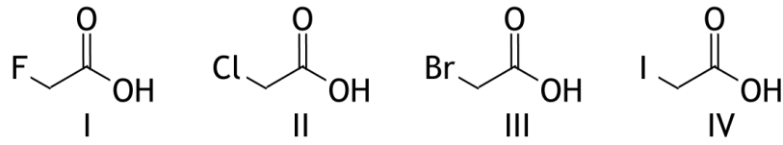
 |  | A |  |  | I
 |  | B |  |  | II
 |  | C |  |  | III
 |  | D |  |  | IV
 |  |  |  |  | pH / acid-base
9 |  |  |  | Equal volumes of 0.10 M solutions of H₃PO₄ and Na₃PO₄ are mixed.  What is the pH of the resulting solution?
 |  | A |  | 4.69
 |  | B |  | 7.21
 |  | C |  | 9.77
 |  | D |  | 12.32
10 |  |  |  |  |  | 20 mL of a solution of sodium hydroxide is added to 20 mL of a solution containing calcium chloride and magnesium chloride, both with a concentration of 0.10 M. The pH is measured and found to be 10.00.  Has a precipitate formed in the solution?
 |  |  | A |  |  | no precipitate has formed
 |  |  | B |  |  | only a precipitate of calcium hydroxide has formed
 |  |  | C |  |  | only a precipitate of magnesium hydroxide has formed
 |  |  | D |  |  | a precipitate of both calcium hydroxide and magnesium hydroxide has formed
 |  |  |  |  |  |  |  | Redox and electrochemistry
11 |  |  |  |  |  |  |  | A pigment often used by the “Old Masters” to obtain a blue colour is the mineral vivianite. Vivianite can be represented by the formula Fe₃(PO₄)₂∙8H₂O. Vivianite is itself colourless, but turns blue after oxidation. Rembrandt and Vermeer, among others, used vivianite in their paintings.  When vivianite is oxidized, the Fe₃(PO₄)₂ reacts with oxygen and water to form iron(III) phosphate and iron(III) hydroxide. The incomplete reaction equation is shown below; only the coefficients are missing.  What is the coefficient for O₂ in the balanced reaction equation?
 |  |  | A |  |  |  |  | 1
 |  |  | B |  |  |  |  | 2
 |  |  | C |  |  |  |  | 3
 |  |  | D |  |  |  |  | 4
 |  |  | E |  |  |  |  | 5
 |  |  | F |  |  |  |  | 6
12 |  |  |  |  |  |  |  | A solution contains equal moles of NiCl₂ and CuBr₂ . The solution is electrolyzed with graphite electrodes.  Which products are produced first ?​
 |  |  |  |  |  |  |  | at the negative electrode | at the positive electrode
 |  |  | A |  |  |  |  | Br₂(aq) | Cu(s)
 |  |  | B |  |  |  |  | Br₂(aq) | Ni(s)
 |  |  | C |  |  |  |  | Cl₂(aq) | Cu(s)
 |  |  | D |  |  |  |  | Cl₂(aq) | Ni(s)
 |  |  | E |  |  |  |  | Cu(s) | Br₂(aq)
 |  |  | F |  |  |  |  | Cu(s) | Cl₂(aq)
 |  |  | G |  |  |  |  | Ni(s) | Br₂(aq)
 |  |  | H |  |  |  |  | Ni(s) | Cl₂(aq)

1 3 |  |  | What is the E⁰ for the half-reaction PbO₂(s) + 4 H⁺(aq) + 4 e— → Pb(s) + 2 H₂O(l) ?  Data:  PbO₂(s) + 4 H⁺(aq) + 2 e— → Pb²⁺(aq) + 2 H₂O(l) E⁰ = 1.468 V  Pb²⁺(aq) + 2 e— → Pb(s) E⁰ = — 0.126 V  Use the formula ΔG = — nFΔE.
 | A |  | 0.671 V
 | B |  | 0.797 V
 | C |  | 1.342 V
 | D |  | 1.594 V
 |  |  |  | Analysis
14 |  |  |  | The vitamin E content of blueberry juice can be determined using gas chromatography. Often an internal standard is used, indicated by the code 85A. This substance does not occur naturally in blueberry juice.  Two chromatograms are then recorded. The results of such a determination are shown below.  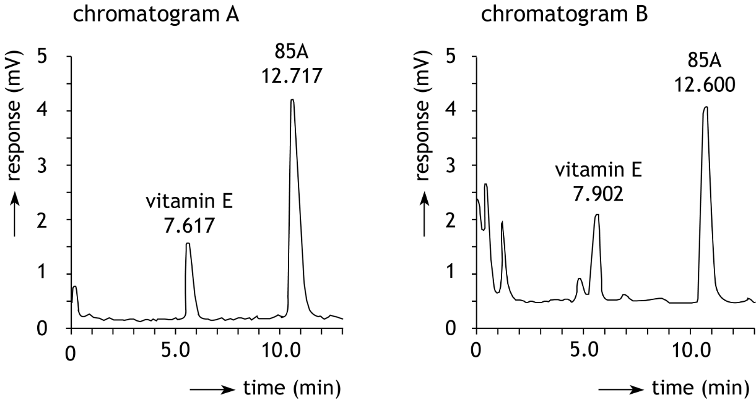  Chromatogram A is of a mixture, in which the concentration of vitamin E  is 4.50·10^{—4} mol L^{—1} and that of 85A is 1.00 ·10^{—3} mol L^{—1}.  Chromatogram B is of a sample of blueberry juice where enough 85A has been added to ensure that the concentration of 85A in that sample is also 1.00 ·10^{—3} mol L^{—1}.  The peak areas are shown above the peaks in arbitrary units.  What was the concentration of vitamin E in the blueberry juice tested?
 |  | A |  | 4.09·10^{—4} mol L^{—1}
 |  | B |  | 4.30·10^{—4} mol L^{—1}
 |  | C |  | 4.71·10^{—4} mol L^{—1}
 |  | D |  | 4.93·10^{—4} mol L^{—1}

The next two questions are about the titration of a solution of a diprotic acid.
In a 250 mL volumetric flask, 1.494 g of the diprotic acid H₂A is dissolved. The solution is filled up to the mark. 25.00 mL of this solution is transferred to an conical flask and titrated with 0.100 M sodium hydroxide solution (caustic soda). The pH during the titration is monitored with a pH meter, and the following diagram is obtained.
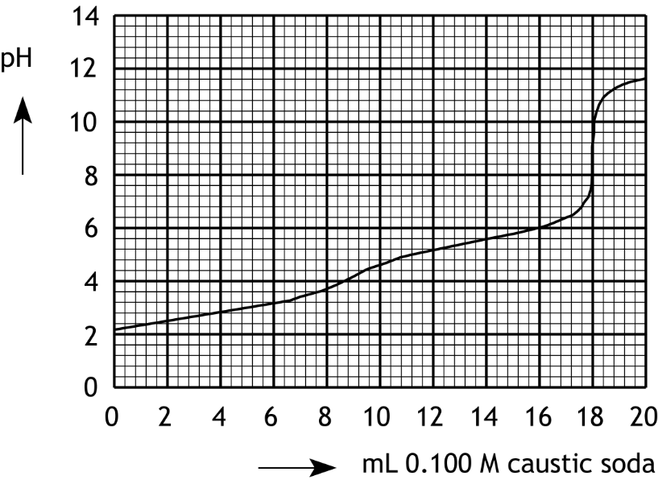

15 |  | The equivalence point of this titration could also be determined using an indicator.  Which of the following indicators would be suitable for this?  I phenolphthalein  II thymol blue
 | A | neither
 | B | only phenolphthalein​
 | C | only thymol blue
 | D | both
16 |  | What is the molar mass of the examined diprotic acid ?
 | A | 21.0 g mol^{—1}
 | B | 42.0 g mol^{—1}
 | C | 83.0 g mol^{—1}
 | D | 166 g mol^{—1}
 | E | 332 g mol^{—1}

 |  |  |  |  | Calculations and Green Chemistry
17 |  |  |  |  | During the combustion of magnesium in air, in addition to magnesium oxide (MgO), magnesium nitride (Mg₃N₂) is formed.  1.000 g of magnesium is combusted. The mass of the produced mixture of magnesium oxide and magnesium nitride is 1.584 g.  What is the mass percentage of magnesium nitride in the mixture?
 |  | A |  |  | 9.0%
 |  | B |  |  | 11%
 |  | C |  |  | 24%
 |  | D |  |  | 90%
18 |  |  |  |  | The metal vanadium can be obtained through the following reaction of vanadium(V) oxide with calcium:  V₂O₅ + 5 Ca → 2 V + 5 CaO  Under certain conditions, this production of vanadium proceeds with a yield of 85 percent.  What is the E-factor of this process?
 |  | A |  |  | 2.7
 |  | B |  |  | 2.8
 |  | C |  |  | 3.2
 |  | D |  |  | 3.4
 |  | E |  |  | 7.8
 |  |  |  | Thermochemistry
19 |  |  |  | An uncatalyzed reaction has an activation energy, E_{a}, of + 50 kJ mol^{—1} and a reaction enthalpy, ΔH_{r}, of — 10 kJ mol^{—1}.  Which of the following shows possible values for E_{a} and ΔH_{r} in the presence of a catalyst?
 |  |  |  | E_{a} |  | ΔH_{r}
 | A |  |  | — 10 kJ mol^{—1} |  | — 50 kJ mol^{—1}
 | B |  |  | + 30 kJ mol^{—1} |  | — 15 kJ mol^{—1}
 | C |  |  | + 30 kJ mol^{—1} |  | — 10 kJ mol^{—1}
 | D |  |  | + 30 kJ mol^{—1} |  | — 5 kJ mol^{—1}
 | E |  |  | + 60 kJ mol^{—1} |  | — 10 kJ mol^{—1}
 | F |  |  | + 60 kJ mol^{—1} |  | + 5 kJ mol^{—1}
 | G |  |  | + 60 kJ mol^{—1} |  | + 10 kJ mol^{—1}
 | H |  |  | + 60 kJ mol^{—1} |  | + 15 kJ mol^{—1}
20 |  |  | What is the bond enthalpy per mole of water for the hydration of copper sulphate? CuSO₄(s) + 5 H₂O(l) → CuSO₄∙5H₂O(s)
 | A |  | ‒ 297 kJ mol^{—1}
 | B |  | ‒ 77.0 kJ mol^{—1}
 | C |  | ‒ 59.4 kJ mol^{—1}
 | D |  | ‒ 15.4 kJ mol^{—1}

Open questions total 58 points
- The decomposition of dinitrogen pentoxide (21 points)
The kinetics of the decomposition reaction of dinitrogen pentoxide in the gas phase have been studied extensively. The reaction equation is:
2 N₂O₅ 4 NO₂ + O₂
Although it can be expected that an equilibrium will be established, the reaction can be considered to proceed to completion at fairly low temperatures.
- Show this by calculating the equilibrium constant at 50 °C. The enthalpy of formation of N₂O₅ is + 11.3 kJ mol⁻¹ and the absolute entropy of N₂O₅ is + 355.6 J mol⁻¹ K⁻¹; use your Data Booklet for additional data. 8
Scientists from the University of Managua (Nicaragua) have investigated the kinetics of the decomposition reaction of dinitrogen pentoxide, dissolved in carbon tetrachloride. Both dinitrogen pentoxide and nitrogen dioxide are soluble in carbon tetrachloride, but oxygen is not. When carried out in carbon tetrachloride, the decomposition reaction is still found to go to completion.
- Give an explanation for why the decomposition of dinitrogen pentoxide goes to completion under these circumstances. 1
The researchers dissolved a certain amount of N₂O₅ in 100 mL carbon tetrachloride and followed the progress of the reaction by measuring the volume of oxygen, V_{t} (in cm³) produced at various times, t. When the reaction is complete (at time t = ), cm³ of oxygen has been formed.
The experiment was conducted at 30 °C and p = p₀.
From the collected data, the concentration of [N₂O₅]_{t} at each time, t, during the reaction can be calculated. The following formula can be used for this calculation: , where F is a multiplication factor.
- Derive this formula and calculate the value of F. 4

When the calculated concentrations of N₂O₅ are plotted against time, the following diagram is produced.
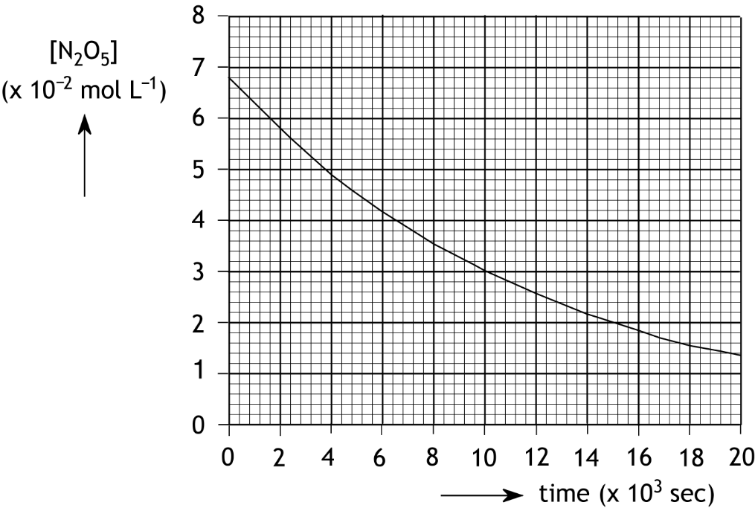

From this diagram, the half-life of the decomposition of dinitrogen pentoxide in carbon tetrachloride under these conditions can be determined, and the reaction can be shown to be a first-order reaction.
- Using the diagram, determine the half-life of the decomposition of dinitrogen pentoxide in carbon tetrachloride under these conditions, and explain why it is a first-order reaction. 4
- Calculate the rate constant, k, under these conditions. 2
The Nicaraguans determined the rate constant in a different way, without calculating the concentrations of N₂O₅ through F. Instead, they plotted against time.
- Explain why this is an appropriate method for determining the rate constant. 2

- Paracetamol (19 points)
Paracetamol is the most commonly used painkiller worldwide. The skeletal structural formula of paracetamol is:
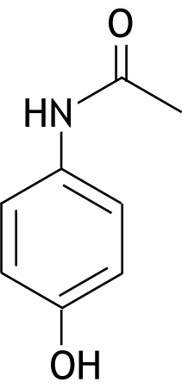

Paracetamol is made by reacting para-aminophenol with a substance X. In the process, another substance, ethanoic acid, is also formed. The reaction has a yield of 90%:
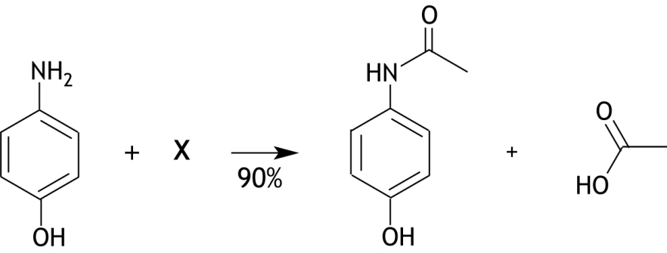

- Give the structural formula of substance X. 1
Para-aminophenol can be produced in various ways. One method involves four conversions with benzene as the initial reactant:
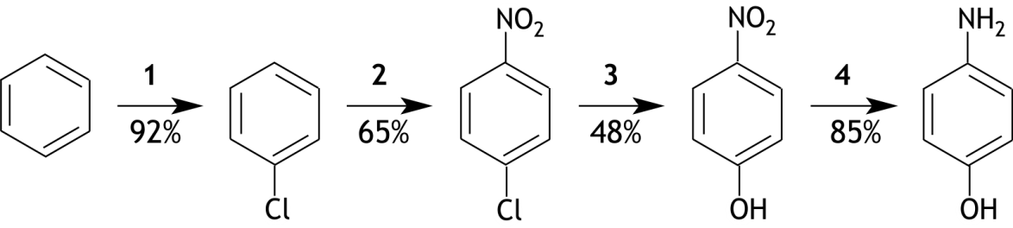

- Give the reaction equations for conversions 1, 2, and 4. Use structural formulas for the
organic compounds. 7
In this synthesis route for para-aminophenol, the benzene ring is first chlorinated and then nitrated.
- Could there be a synthesis route for para-aminophenol that starts with the nitration of
benzene? If you think there is, explain how that synthesis route should proceed.
If you think there is not such a synthesis route, explain why not. 3
In conversion 3, severe conditions must be applied, as nucleophilic substitution reactions generally do not occur on benzene rings. The para-nitrochlorobenzene first reacts with molten sodium hydroxide at a high temperature, and the reaction product is then treated with hydrochloric acid.
It is assumed that in the first step of the mechanism of this conversion, an OH⁻ ion binds to an H⁺ ion from a para-nitrochlorobenzene molecule, resulting in a molecule with the following structure:
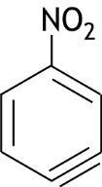

- Show the formation of this intermediate in a reaction equation with structural formulas;
- draw all relevant lone pairs;
- place any formal charges correctly;

- indicate the movement of electron pairs with curly arrows ( ). 3
Next, a second OH⁻ ion reacts, leading to the formation of a para-nitrophenolate anion in two steps:
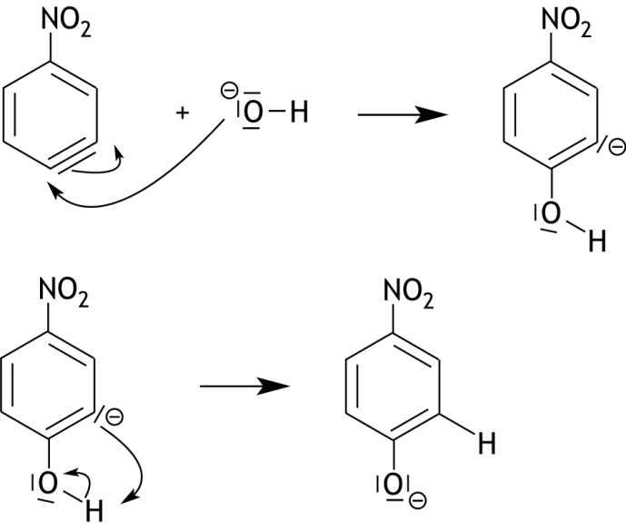

Finally, after acidification, para-nitrophenol is formed.
Para-nitrophenol is not the only organic product formed according to this mechanism in this reaction.
- Give the structural formula for the other organic product formed. 1
In the reaction schemes above, the yield of the listed conversions is shown.
- Using this data, calculate how many tons of paracetamol can be produced from 1.00 ton of benzene. 4

- Wüstite (18 points)
Wüstite is a mineral with the formula Fe_{x}O. The value of x is dependent on the formation process of the mineral and ranges from 0.85 to 0.95. The fact that x is less than 1 is due to the presence of both Fe²⁺ and Fe³⁺ ions in wüstite.
- Calculate the molar ratio between Fe²⁺ and Fe³⁺ in wüstite with the formula Fe_{0.87}O.
Write down your answer as Fe²⁺ : Fe³⁺ = … : 1.0. 3
Wüstite crystallises in the same way as NaCl. The unit cell of NaCl is shown below.
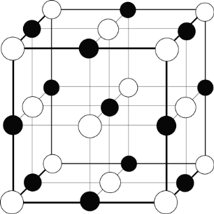

In the NaCl crystal, all positions in the crystal lattice are occupied, but in wüstite crystals, ‘gaps’ are present: on some positions in the crystal lattice ions are missing.
- Give an explanation for this. 1
A certain type of wüstite has a density of 5.71·10³ kg m⁻³. Using X-ray diffraction, it is determined that the shortest distance between the nuclei of two ions is 214 pm.
- Calculate the value of x in this type of wüstite. 6
The value of x in Fe_{x}O can also be determined by means of a titration with a potassium permanganate solution.
To determine the value of x in a second, different type of wüstite, 250 mg of wüstite is dissolved in an excess of dilute sulphuric acid. The resulting solution is titrated with a 0.0200 M potassium permanganate solution. The following reaction occurs:
5 Fe²⁺ + MnO₄⁻ + 8 H⁺ → 5 Fe³⁺ + Mn²⁺ + 4 H₂O
For the titration, 26.41 mL 0.0200 M potassium permanganate solution is required.
- Calculate the value of x in this type of wüstite. 8

Green Chemistry

The twelve principles of green chemistry are:

1. Prevention Preventing waste is better than treating or cleaning up waste after it is created.
2. Atom economy Synthetic methods should try to maximize the incorporation of all materials used in the process into the final product. This means that less waste will be generated as a result.
3. Less hazardous chemical syntheses Synthetic methods should avoid using or generating substances toxic to humans and/or the environment.
4. Designing safer chemicals Chemical products should be designed to achieve their desired function while being as non-toxic as possible.
5. Safer solvents and auxiliaries Auxiliary substances should be avoided wherever possible, and as non-hazardous as possible when they must be used.
6. Design for energy efficiency Energy requirements should be minimized, and processes should be conducted at ambient temperature and pressure whenever possible.
7. Use of renewable feedstocks Whenever it is practical to do so, renewable feedstocks or raw materials are preferable to non-renewable ones.
8. Reduce derivatives Unnecessary generation of derivatives — such as the use of protecting groups — should be minimized or avoided if possible; such steps require additional reagents and may generate additional waste.
9. Catalysis Catalytic reagents that can be used in small quantities to repeat a reaction are superior to stoichiometric reagents (ones that are consumed in a reaction).
10. Design for degradation Chemical products should be designed so that they do not pollute the environment; when their function is complete, they should break down into non-harmful products.
11. Real-time analysis for pollution prevention Analytical methodologies need to be further developed to permit real-time, in-process monitoring and control before hazardous substances form .
12. Inherently safer chemistry for accident prevention Whenever possible, the substances in a process, and the forms of those substances, should be chosen to minimize risks such as explosions, fires, and accidental releases.

atom economy
percentage yield
E -factor

46th National Chemistry Olympiad 2025 preliminary round 2
Answer sheet: multiple choice questions

name:

no. | answer  (letter) | (score)
1
2
3
4
5
6
7
8
9
10
11
12
13
14
15
16
17
18
19
20
 | Total

